# 3.5 The installation and operation of a pneumatic gripper

The KUKA AGILUS offers numerous options for different end-effectors installations. One of the most common end effectors is a gripper, whether it be vacuum, pneumatic, hydraulic or servo-electric grippers. We are concerned with pneumatic grippers, which operate using air pressure. When air pressure is applied on the pistons, the gripper closes. When the pressure is released the gripper opens. The only way to manage the force in the gripper is to manage the air pressure in the air intake (or valve). The gripper used in our study is the SOMMER automatic GP 404 NC-C We also had the opportunity to work with one of KUKA Roboter’s Application software; Gripper&SpotTech. These are ready-made software packages created for different industrial applications. Optional features can be installed on the controller easily and quickly and can also be tailored to the specific production environment.

These software include, and not limited to, KUKA.ArcTech, which enables implementation and programming of applications for arc welding and plasma cutting, KUKA.ConveyorTech, which automatically adapts the actions of the robot to the motion of an assembly line or conveyor belt and KUKA.CNC, which links the CNC and robot directly to each other. As a result, they can be operated like a conventional CNC controller.

Pneumatic grippers can be used in many applications, some of which include assembly purposes, Labs automation, and on mobile robots.

This software package offers numerous advantages, including:

* 16 freely configurable grippers
* 256 configurable welding programs
* Gripper conditions statically and dynamically monitored
* Unlimited user-defined gripper icons
* Freely programmable fault elimination routines
* Graphical user interface with indicator lamps, a status display and online adaptation
* Adaptation via WorkVisual 4.0 and on the smartPAD for production-relevant elements

## 3.5.1 Gripper connection:

The gripper is connected to the air supply through the Air 1 port located on link 3 (The port is shown in the following picture). This port is connected internally to Air 1 port on the back of the robot arm, which in turn is connected with the air compressor.

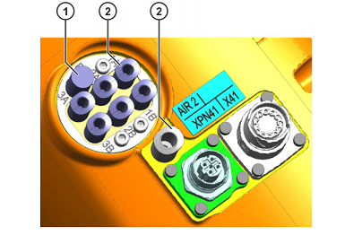

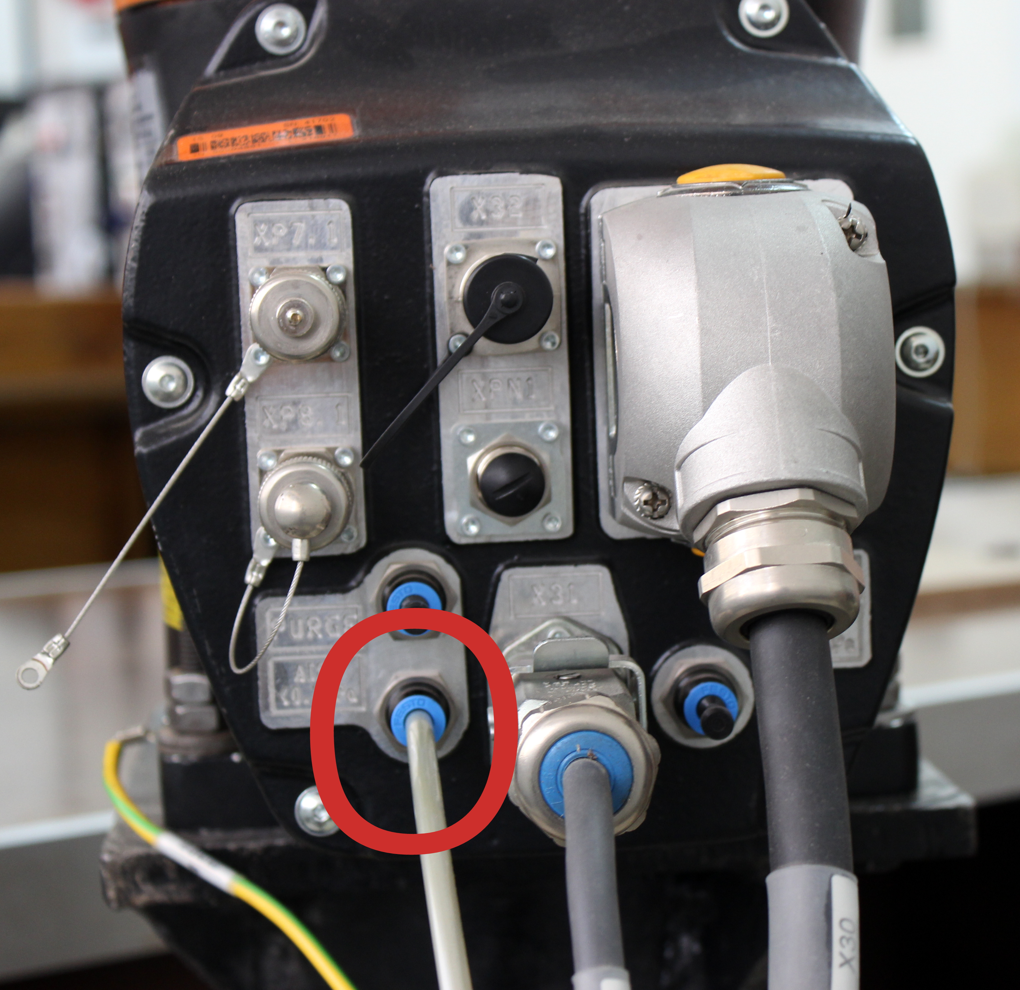

## 3.5.2 Configuring predefined grippers

Gripper settings can be changed using smart pad. In the main menu, select **Configure** > **I/O** > **Gripper**. A window opens (shown in figure), inside it you’ll find a list of the predefined grippers, select the desired gripper number with **Next** or **Previous**.

You can change **number of grippers )1), Name of gripper (2), Type of gripper (3), designation of gripper type (4), Assignment of the output numbers (5), Assignment of the input numbers (6) and Switching states (7).**

The third cell, designated for the type of gripper is explained in the following section*, Predefined gripper types.*

### Predefined gripper types

There are five predefined gripper types in Gripper&SpotTech. If these types are not sufficient, additional gripper functions can be programmed.

* Type 1: **Single-element gripper, static, open/closed**
* Type 2: **With mid-position valve**
* Type 3: **Vacuum gripper with 2 valves**
* Type 4: **Vacuum gripper with 3 valves**
* Type 5: **Single-element gripper with pulse valves, open/clo**

*More information about the specifications of each type and user specified grippers can be found in manual* ***“KST_GripperSpotTech_32_en”.***

## 3.5.3 Gripper operation

Manual gripper control can be performed using technology keys on smart pad. The settings for the technology keys are already set for this gripper and appear with the following icons on the smart pad screen, next to the assigned buttons.

|  |  |
| --- | --- |
| Icon | Description |
|  | Select gripper  The number of the gripper is displayed.   * Pressing the upper key counts upwards. * Pressing the lower key counts downwards. |
|  | Toggle between the gripper states (e.g. open or close) |

The gripper is opened or closed using these buttons, after pressing the enable buttons on the back of the smart pad. They can also controlled inside KRL programs in inline form through the following command



Where

1. Choosing the desired gripper from a list of predefined grippers in settings
2. Sets the state of the gripper, whether to open or close
3. **CONT**: Execution in the advance run
4. Box only available if **CONT** selected.

* START: The gripper action is executed at the start point of the motion.
* END: The gripper action is executed at the end point of the motion.

1. Box only available if CONT selected.

Define a wait time (-200:200 ms), relative to the start or end point of the motion, for execution of the gripper action.

1. Box only available if [blank] selected.

Data set with gripper parameters

References

1. KUKA manuals “KST_GripperSpotTech_32_en”
2. <http://blog.robotiq.com/bid/72815/Top-5-Applications-for-Robotic-Electric-Grippers>